Appendix A

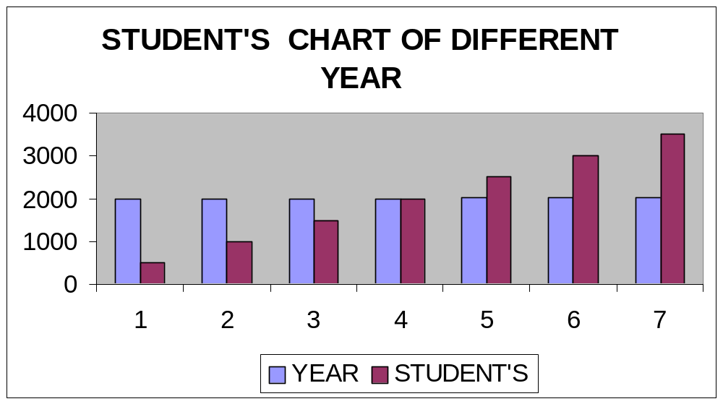

FIG: STUDENT’S CHART OF DIFFERENT YEAR

Feasibility work plan and Gantt chart

Review Initial Study Data
Plan and Conduct Feasibility Study
Interview Review Present System

Define Objective of Proposed System
Identified Alternatives
TASK

Evaluate Cost and Benefit Analysis

Prepare Feasibility Study Report

1 2 3 4

Days

Legend:
Start date:
End date:

